**GMTK game jam**

**(working titles)**

* The Alchemist Runs from Responsibility
* Vertically Challenged Rest
* Short and Tired
* you’re short POV
* From Downtown
* Potent Potion
* Eepy Teeny Witchy

———————————————————————————

**Concept:**

* Metroidvania type game where the player needs to get smaller to be able to win/escape
* The player character becomes weaker over the course of the game instead of the enemies becoming stronger
* Becoming smaller will allow the player character to fit through narrow gaps and crevasses to be able to find new paths and upgrades
* Collect ingredients

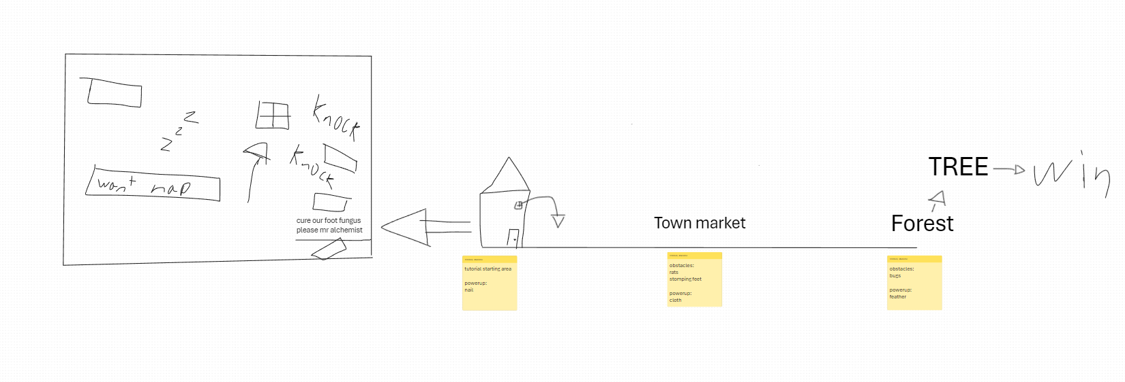

**Setting:**

* Medieval/fantasy

**Enemies:**

**Upgrades:**

* Become smaller
* Become smallerer
* Become smallererer
* Feather jump (double jump)
* Glider (piece of cloth)
* *Swim through the air?*
* Wall-Climb (nail to wall)

**Packages:**

* TextMeshPro
* *FMOD
* Input sytem